NAME:____________________________________________

DATE:___________________
HOLY SAVIOUR (CUREPE) ANGLICAN SCHOOL
SOCIAL STUDIES
CHRISTMAS TERM TEST

This test consists of two (2) sections.
Section 1: Multiple Choice
30 Questions at 1 mark each =30 marks
Section 2: Structured questions
6 structured questions at 5 marks each= 30 marks
Answer ALL questions.
WORK CAREFULLY
Time: 75 minutes

SECTION 1
MULTIPLE CHOICE
This section consists of 30 questions. Read each question carefully and then circle the most appropriate choice. Each question is worth 1 mark.
Example: Slaves were brought from
- Australia
- America
- Africa
- India

- Which one of the following is a healthy practice?
- Alcohol use
- Over eating
- Regular exercise
- Smoking cigarettes

- During his leisure time, Paul learnt about the history of Trinidad and Tobago. Which place did he most likely visit?
- Beach
- River
- Zoo
- Museum

- Bernard saw this sign at Maracas Beach.

LEAVE NOTHING BUT FOOTPRINTS.

This means that Bernard should
- Take off his shoes at the beach.
- Leave the beach as clean as he met it.
- Throw his garbage into the sea.
- Bathe in the nude.

- Which of the following can be considered as leisure?
- Painting the house.
- Washing the dishes.
- Listening to music.
- Selling goods.

Questions 5 to 7 are based on the map below.
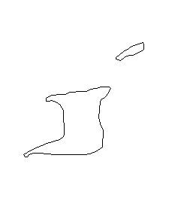

- The wetland at A is most likely the:
- Caroni Swamp
- Oropouche Lagoon
- Nariva Swamp
- None of the above

- Mr. Green is a tourist visiting from England. He has heard about our National Bird, the Scarlet Ibis and would like to tour the area where this bird nestles. Where on the map would he most likely visit?
- A
- B
- C
- D
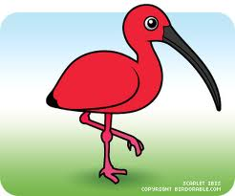

- The body of water at X is most likely:
- The Columbus Channel
- The Gulf of Paria
- The Atlantic Ocean
- The Caribbean Sea

8) A tourist wants to visit the highest mountain peak in Trinidad. Which would he most likely visit?
- Central Range
- Southern Range
- Northern Range
- San Fernando

9) Which of the following is a benefit of leisure?
- Enjoyment
- Relaxation
- Good Health
- All of the above

10) Who of the following can be considered a tourist?
- Greg visits our country to invest
- Brady comes to live in our country
- Latifah visits for a vacation
- Derrick leaves our country to live abroad

11) The chain of Caribbean Islands is an example of what land form?
- Archipelago
- Peninsula
- Isthmus
- Plain

Questions 12 and 13 are based on the diagram of the water cycle.
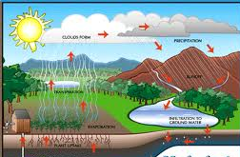
Y
12) The process at Y is most likely
- Precipitation
- Transpiration
- Condensation
- Evaporation

13) If the trees were cut down, which of the following could be the result?
- Less transpiration
- Soil erosion
- Flooding
- All of the above

14) In which year was our national Flag first flown?
- 1962
- 1976
- 1956
- 1498

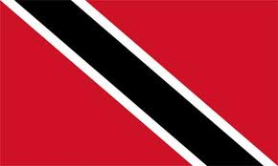

15) “Our watchwords” are
- Discipline, Tolerance, Production.
- Here every creed and race finds an equal place.
- Together We Aspire, Together We Achieve.
- I will honour those in Authority.

16) What would prevent tourists from visiting Trinidad and Tobago?
- The friendliness of the people.
- An increase in criminal activity.
- Celebration of Carnival festivities.
- Construction of more highways.

17) In what year did Trinidad and Tobago become a Republic?
- 1834
- 1835
- 1976
- 1972
Question 18 is based on the diagram below.

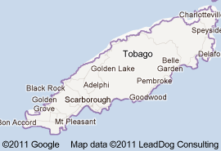
550mmm

- What landform is most likely to be found at 550m?
- Mountain
- River
- Swamp
- Hill

Question 19 is based on the picture below.

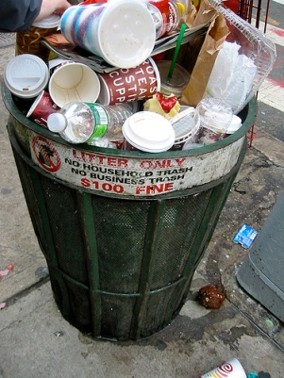
19) If you had gone to use this bin, what would you do?
- Place the garbage next to the bin.
- Throw it in a nearby drain instead .
- Look for another bin to use.
- Put it at the side of the road.

Question 20 is based on the diagram below.

X

21) What is the name of the body of water located around X?
- Atlantic Ocean
- Caribbean Sea
- Columbus Channel
- Gulf of Paria

22) Which of the following is a NATURE site that tourists may want to visit?
- The Red House
- Dwight Yorke Stadium
- Magnificent Seven
- Caroni Swamp

23) What is the name of the Hindu Festival that celebrates the triumph of good over evil?
- Eid-ul- Fitr
- Divali
- Phagwa
- Hosay
24) The Devil’s Woodyard in Trinidad is the site of
- Mud Volcanoes
- The Mystery Tombstone
- A dense forest
- A haunted house

- Which of these is the longest river in Trinidad?
- The Navet River
- The South Oropouche River
- The Caroni River
- The Ortoire River

- In which mountain range would you find the Trinity Hills?
- Northern Range
- Central Range
- Southern Range
- None of the above

- The first President of Trinidad and Tobago was:
- Sir Solomon Hochoy
- Sir Ellis Clarke
- Dr Eric Williams
- Mr. Albert Gomes

- Our national flower was named after our last Spanish Govenor who was:
- Don Jose Maria Chacon
- Christopher Columbus
- Sir Solomon Hochoy
- Dr. Eric Williams

Question 29 is based on the statements below.
I will strive
In everything I do
To work together with my fellowmen
Of every creed and race

- These lines from the National pledge tell us that we must strive to work together with
- Different groups of people
- One group of people
- My friends only
- With men only

- Which of these birds is not found on the Coat of Arms?
- Cocrico
- Scarlet Ibis
- Humming bird
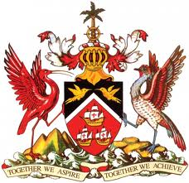
- Dove

SECTION 2
STRUCTURED QUESTIONS
There are six questions in this section. Read the questions and study the diagrams or graphs carefully. Write your answers on the lines provided. Each question is worth 5 marks.

Question (1) THE WATER CYCLE
B
A

The Water Cycle
- Name the process at A__________________________________ 1 mark

b) Suggest what will happen to surface water if there is an increase in rainfall
________________________________________________________________________________________________________________________________________________________________________________________________________ 2 marks

c) Suggest what can happen when rain falls on hillsides where there are no trees.
_________________________________________________________________________________________________________________________________________________________________________________________________________________________________________________________________________________ 2 marks
TOURISM
Question (2) Answer the following questions based on the map below.

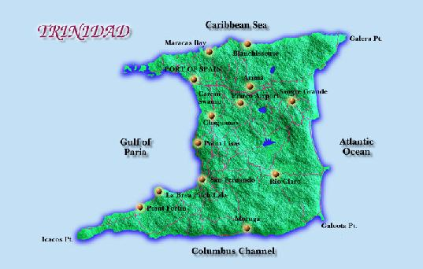
B
A
- The nature reserve at A is most likely the
_______________________________________________________________ 1 mark
- The historical site at B is most likely the
( ) Temple in the Sea ( ) Fort George
( ) Light house ( ) National Museum
1 mark

- Give two benefits to be derived from tourism.
1_________________________________________________________________________

2_________________________________________________________________________
2 marks
Give one negative impact of tourism.
- _________________________________________________________________________

OUR NATION
Question (3) As a result of our becoming an independent country, Trinidad experienced several changes. Name two of these changes.
- ______________________________________________________________________
________________________________________________________________________
- ___________________________________________________________________________________________________________________________________________
( 2 marks)
“When Trinidad and Tobago became a Republic the Independence Constitution was changed and replaced by the new Republican Constitution.”

Explain in your own words what the Constitution is.
________________________________________________________________________________________________________________________________________________________________________________________________________________________
( 1 mark )
- Name two places where our Coat of Arms can be displayed.
1________________________________________________________________
2________________________________________________________________

HOW AND WHERE I SPEND MY TIME
Question (4)
Study carefully the following table which shows how two students Chad and Roger spend their Saturdays during the same hours. Based on the information given, answer the following questions.
CHAD | ROGER
Time Activity  AM 6:00-8:00 Watch TV  AM 9:00- 10:00 Listen to Music  AM 11:00-12:00 Reads a Book  PM 2:00-300 Swimming  PM 4:00-8:00 Cinema | Time Activity  AM 6:00-8:00 Study  AM 9:00- 10:00 Chores  AM 11:00-12:00 Cricket  PM 2:00- 3:00 Swimming  PM 4:00- 8:00 Farming & music lessons

- Which student spends more time at leisure and recreational activities?
_______________________________________________________________ 1 mark

- Name an activity that both students engage in at the same time.
______________________________________________________________1 mark
- Name an activity that can be classsified as work.
____________________________________________________________1 mark
- Why do you think Roger prefers to study early in the morning?
_____________________________________________________________2 marks

Question (5) NEED FOR GOOD HEALTH
Question 6) Some adults are sometimes not the best role model for us since they practise some unhealthy habits.
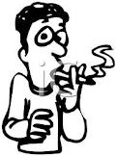
- Observe the picture and state two negative effects of this habit.
i)______________________________________________________________________________________________________________________________________________ii)______________________________________________________________________________________________________________________________________________
( 2marks)
b) Your friend’s dad has a serious drinking problem. Say how this problem could affect
i) him _________________________________________________________________________
ii) his family
__________________________________________________________________________
iii) others
__________________________________________________________________________

(3marks)

6) a. Your Standard Four class has been asked by your teacher to make a list of “Do’s and ‘Don’ts’ for your behaviour in the classroom.
Write these activities in the correct column for a classroom chart.
Activities
Throw waste paper and wrappers on the floor
Obey the school rules
Be courteous to others
Deface the wall
Run on the desks
Pay attention

Do’s | Don’ts

5 marks

